Instructions for Use

\*product may not be exactly as shown, terms and conditions apply

Some more obvious buttons are not mentioned, because.

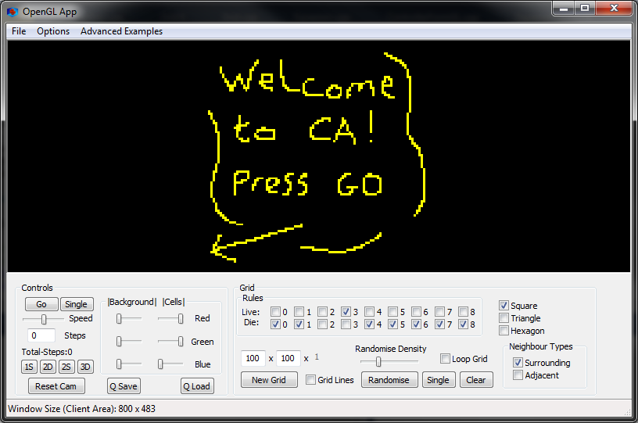

\*1

\*6

\*8

\*4

\*7

\*5

\*3

\*2

1. Menu
   1. File – Pretty self-explanatory. Allows for saving, loading and exiting
   2. Options
      1. Sync Display – when enabled will ensure that the next CA step will be drawn in its entirety. Disabling this can speed up larger grids but will cause tearing.
      2. Advanced Rules – Toggles advanced rule UI (UI explained below)
   3. Advanced Examples – Here are listed some “complex” examples of CA. In this instance “complex” simply means that it is hard coded with the program as it contains features that the user cannot replicate. You will not be allowed to save while one is active, although you can change the grid size and draw.
2. Controls – Mostly deal with setting the CA type and speed
   1. Go – (duh)
   2. Single – performs a single step
   3. Speed – (also duh)
   4. Steps – Enter a number and press go, the simulator will run that number of steps
   5. Types of CA
      1. 1S – 1 Dimensional step CA incremented in 2D
      2. 2D – 2 Dimensional CA
      3. 2S – 2 Dimensional Step CA incremented in 3D
      4. 3D – 3 Dimensional CA
      5. 3S – Doesn’t exist because OpenGL doesn’t support 4D
3. Quick save and load – saves and loads the current grid and rules
4. Grid creation
   1. New Grid – Create a new grid of the dimensions specified next to the button
   2. Grid Lines – Toggles if a grid is overlaid in 2D or outlines 3D cubes
   3. Randomise – Randomises the grid of the density 0-100% based on the drag bar
   4. Single – Wipes the grid and places a single live cell in the centre of the grid
   5. Clear – Wipes the grid clean
   6. Loop Grid – Toggles weather or not the grid loops around at the edges
5. Rule Checkboxes – The centre of all CA
   1. Live – if an empty cell is surrounded by this number of live cells. It will become alive
   2. Die – if a live cell is surrounded by this number of live cells. It will die
6. OpenGL Window – Outputs the CA to the screen but can also take mouse input
   1. Left Click – Moves the grid
   2. Right Click – Rotates the grid
   3. Scroll – Zooms in/out
   4. CTRL (hold down) – Draw mode: Snaps the grid temporarily for easier drawing
      1. Left Click – Draws live cells (currently only supported in square/cube grids)
      2. Right Click – Erases cells
      3. Middle Mouse – Draws “wall” cells that do not react to live cells
      4. Scroll – In 3D grids this will cut through the grid showing a cross section
7. Tessellation – The shapes of the cell: square, triangle and hexagon
8. Neighbour types – e.g. For squares “Surrounding” sets all 8 of the surrounding cells as the neighbours whereas “Adjacent” sets the neighbours as the 4 cells with touching edges.

Advanced Rules (“Spiral.mca”):

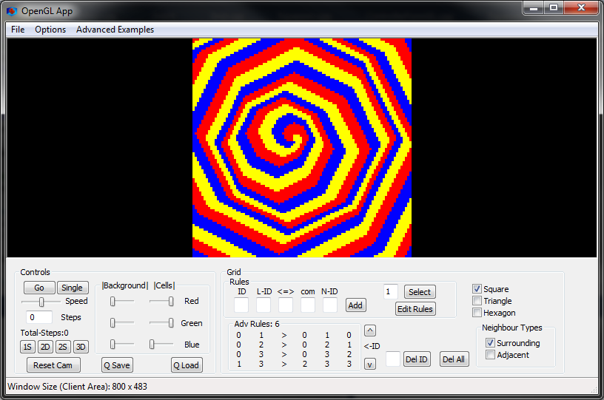

\*3

\*2

\*1

\*4

\*5

1. Add rule boxes and button:

ID: The ID that the cell should be to do the rule

L-ID: The “look for” ID: The cell will look at its neighbours for this ID

<=>: How the rule will treat the number of “look for” neighbours

Com: “Compare” the number to compare to the number of “look for” neighbours

N-ID: “New ID” the ID the cell is to become if the rule is successful

Here is an example of how to enter a rule and what exactly it does:

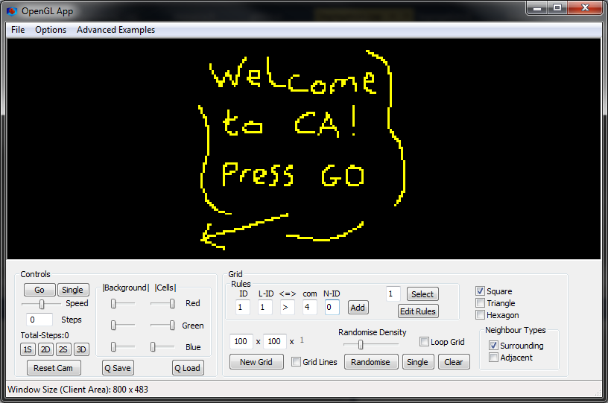

This means that if the cell has an ID of 1 and there are more than 4 neighbours with an ID of 1 it will now have an ID of 0. Or more simply it can be read as: If a live cell has more than 4 live neighbours it will die.

1. ID Selection – Enter the ID of the cell type you wish to select (default 1) and hit select. You will now be able to draw that ID onto the grid and change that IDs colour.
2. Edit rules – This toggles weather the rule table and delete buttons are visible.
3. Rules table – This shows all current rules that are applied to the current grid. The numbers shown correspond to the textboxes directly above them.
4. Deleting Rules
   1. Del All – deleted all rules currently assigned to the grid
   2. Del ID – deletes the rule with the given ID you set in the text box. The ID of each rules is shown on the far right of the rule table (highlighted in the black box)